Customize Switch with Network modules using Cisco Packet Tracer

EXPNO:06 SHARMILEE B

DATE:29.08.2024 231901049

AIM:

To Customize Switch with Network Modules using Cisco Packet Tracer

1. Open Cisco Packet Tracer

Launch Cisco Packet Tracer on your computer.

1. Add a Switch to Your Workspace In the device toolbar (usually on the left side of the screen), locate the "Switches" section.

Drag and drop a switch model onto the workspace. For instance, you might choose a model like the "2950" or "2960."

1. Access the Switch’s Physical Layout
   * Click on the switch in the workspace to open its configuration window.
   * Navigate to the "Physical" tab to see the switch's physical layout and modules.
2. Add Network Modules
   * In the "Physical" tab, you might see options to add or modify network modules.
   * Click on the slot where you want to add a module. You can choose from available modules such as different types of Ethernet or Fiber modules.
   * Drag the module from the list of available modules and drop it into the slot on the switch.
3. Configure the Modules After adding the module, switch to the "Config" tab in the switch’s configuration window.

Here, you can configure the ports provided by the module. For example, you can set IP addresses, VLAN configurations, and other settings for the new interfaces.

1. Configure the Switch Ports
   * Switch to the "Config" tab to configure ports on the switch. Here, you can set parameters for each port.
   * Select the specific port or range of ports you want to configure. You can set parameters such as VLAN assignments, port descriptions, and more.
   * For example:
     + To configure a port to be in a specific VLAN:
       - Select the port or range of ports.
       - Assign the VLAN ID under the VLAN settings. o To set a description for the port:
       - Enter a description in the "Description" field.
2. Using the CLI for Detailed Configuration
   * Switch to the "CLI" tab for command-line interface access.
   * Enter configuration commands to set up the switch. Here’s an example of how to configure VLANs and interface settings via CLI:

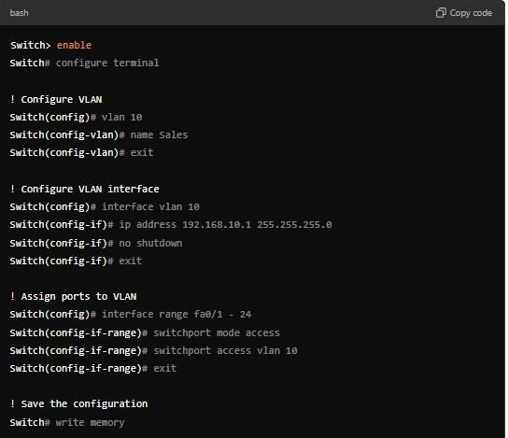

1. Save Your Configuration

Once you’ve configured the modules and ports, be sure to save your configuration. Use commands in the CLI (Command Line Interface) if you’re using a model that supports CLI commands.

For example:

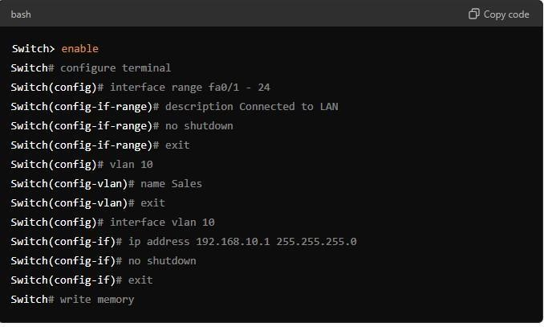

1. Test Your Configuration
   * Use the simulation mode to test the network configuration.
   * Add devices (PCs, routers, etc.) and connect them to the switch to ensure that everything is working as expected.

Output:

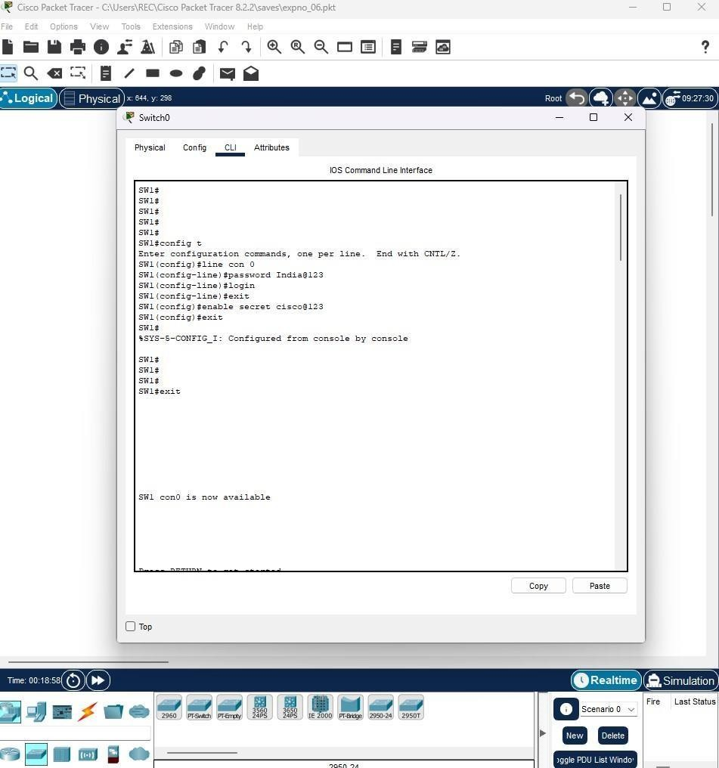

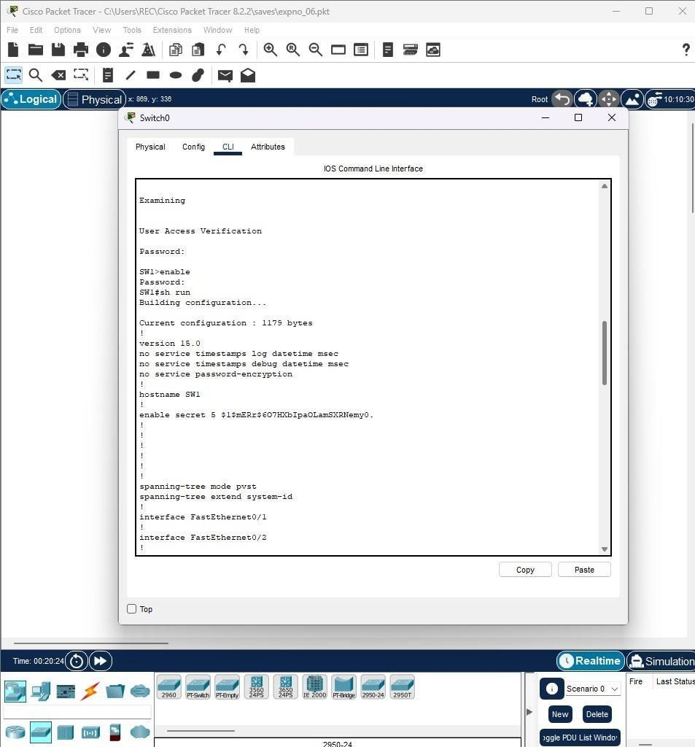

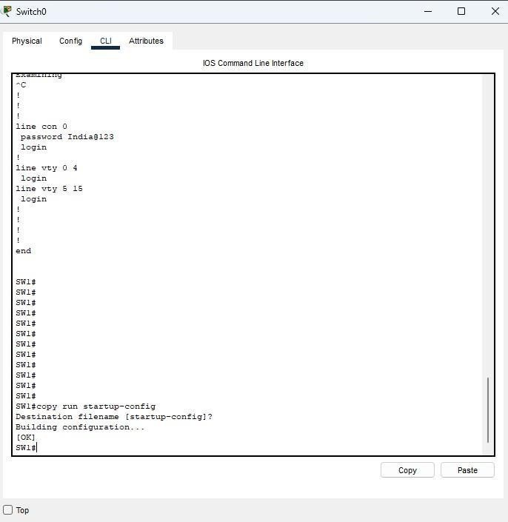

Result:

Switch with Network Modules using Cisco Packet Tracer is Customized.